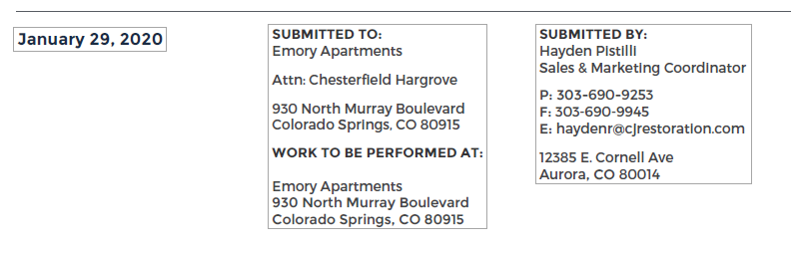

**Scope of Work**

______________________________________________________________________________

* Gutter Repair
* Soffit Repair to include damage drywall patch

_____________________________________________________________________________

Sub-total: $1,000.00

Estimates Taxes / Permit Fees: $0.00

Proposed Total: $1,000.00